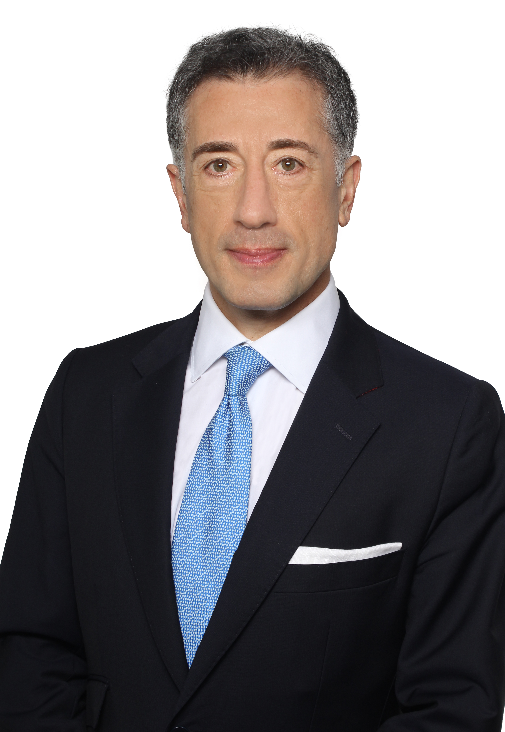 | Prof. Dr. Georges Affaki, C.Arb, FCIArb  Independent Arbitrator  10, avenue Hoche, 75008 Paris  T. +33 1 55 73 74 78, georges.affaki@affaki.fr  www.affaki.fr

Georges Affaki is a Professor of law at the University of Paris II and an Avocat admitted to practice before the Court of Appeal of Paris, France. He is a Chartered Arbitrator, a member of the ICC International Court of Arbitration and of the ICSID Panels of Arbitrators and Mediators. He served as chairman, panel and sole arbitrator in investment and in international commercial arbitral proceedings under the rules of the leading institutions.

Prof. Affaki is a Fellow of the Chartered Institute of Arbitrators and a Fellow of the Australian Centre for International Commercial Arbitration (ACICA). He is consistently ranked by Euromoney in the Guide to the World’s Leading Experts in Commercial Arbitration and is listed by Chambers both amongst France’s Most in Demand Arbitrators and for his expertise in financial regulation and litigation.

He is the Chairman of ICC France Banking Commission and chairs the Legal Committee of the ICC Banking Commission that he founded. Professor Affaki is a member of the Board of Governors of the UNIDROIT Foundation and a Council member of the ICC Institute. He led or participated in several law reforms in transition economies. In 2019, Prof. Affaki was nominated Foreign Trade Counselor of France by Ministerial Decree.

Prof. Affaki co-chaired the ICC Task Force on Financial Institutions and International Arbitration. He also chaired the French Arbitration Committee working group on Arbitration in Banking and Financial Matters. He acted as Rapporteur for the International Law Association Resolution on international jurisdiction over foreign bank branches, and chaired a Paris Europlace working group on Islamic Finance which issued a report titled Applicable Law and Dispute Resolution in Islamic Finance.

He is the author or editor of several books, including “Trade Finance”, ITC Publishing; “Cross-border insolvency and conflicts of jurisdictions”, Bruylant; “Increasing Access to Credit – Reforming Secured Transaction Law”, ITC Publ.; “The Guide to ICC Uniform Rules for Demand Guarantees” (with Sir Roy Goode), ICC Publ. No. 702; “Jurisdictional Choices” (with Horacio Grigera Naon), ICC Publ. No. 755, and over 80 articles and case notes on international arbitration and litigation, international banking, economic sanctions, cross-border insolvency, and Islamic finance.

Prof. Affaki is fluent in Arabic, English and French.

He holds trustee positions in a number of non-profit organisations and is actively engaged in community projects. He was awarded the European Prize for Interdisciplinary Research.

A list of Prof. Affaki’s representative arbitrator, counsel and expert appointments are available at www.affaki.fr.

