Laurence Li, S.C., J.P.
Senior Counsel, Temple Chambers

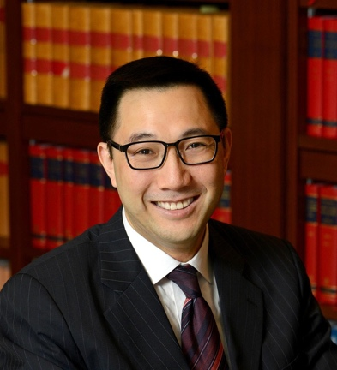
Brief Bio
Laurence Li was called to the Hong Kong Bar in 2006 and appointed Senior Counsel in 2019.
Mr. Li’s practice focuses on financial, company, and commercial law. He is regarded by many as the foremost practitioner in Hong Kong for securities and regulatory matters. He regularly acts for banks and securities firms, investors, listed companies, their directors and shareholders, accountants, valuers, the regulators, and the Government in a full range of cases.
Mr. Li speaks fluent Putonghua and also often acts in Mainland-related disputes.
Prior to joining the Hong Kong Bar, Mr. Li served in several positions within the Securities and Futures Commission and, before that, worked in one of the top law firms in New York.
Mr. Li received his B.A. from Yale University and his J.D. from Harvard Law School.
Mr. Li is the current Chairperson of the Financial Services Development Council, an advisory body to the Government on the development of Hong Kong’s financial industry and markets. He is also a Justice of the Peace and has been appointed a Judge of the Regulatory Tribunal at the Qatar International Court.
Always keen to share his experience and knowledge, Mr. Li is the General Editor of Sweet & Maxwell’s annual edition of Securities and Futures Ordinance: Commentary and Annotations, and is a Senior Fellow of the Centre for Financial Regulatory and Economic Development at The Chinese University of Hong Kong as well as an Honourary Fellow of the Asian Institute of International Financial Law at The University of Hong Kong.

